MPOWER-TWG research collaboration launch

Sir Stephen Tindall Learning Centre, The Warehouse Group headquarters, Northcote

5 March 2015

Some audience members

Andrew Bhimy (Head of Retail Careers, TWG) opens the launch

Mark Powell (CEO, The Warehouse Group) on the research collaboration

Mark Powell (CEO, The Warehouse Group) on the research collaboration

Research presentation 1: Jarrod Haar (Massey) on business and leadership

Research presentation 1: Jarrod Haar (Massey) on business and leadership

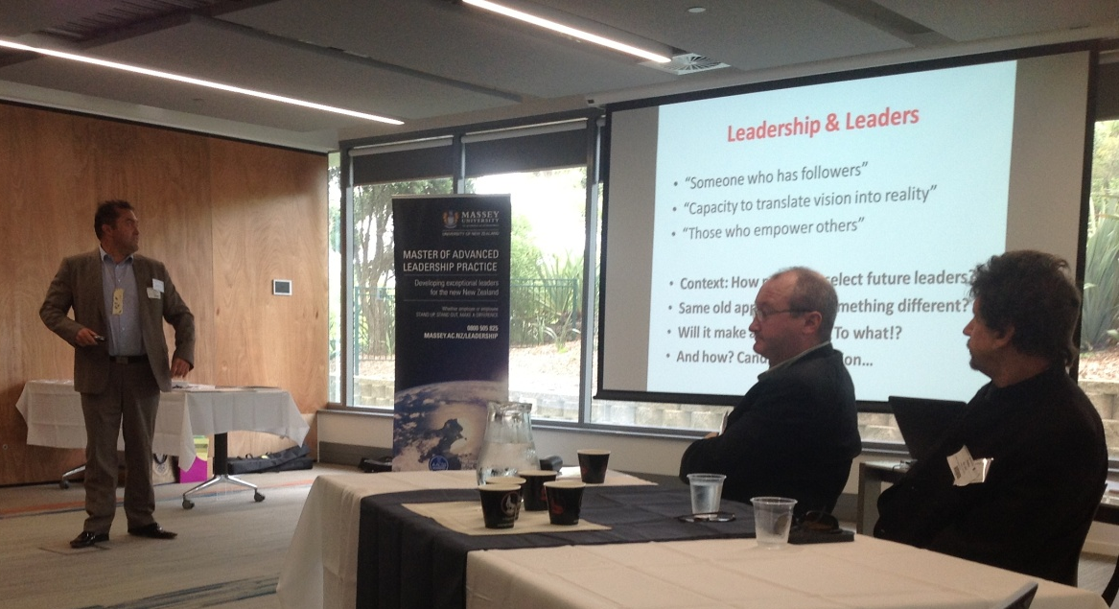
Research presentation 1: Jarrod Haar (Massey) on business and leadership

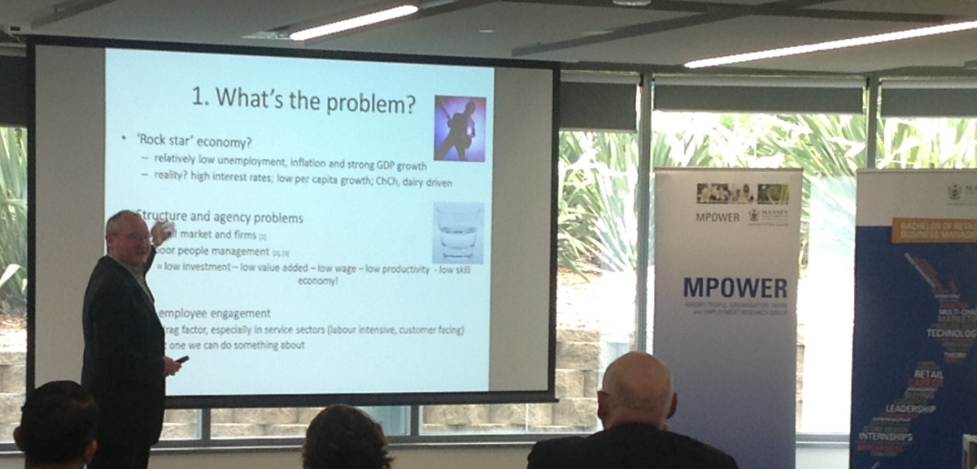
Research presentation 2: Jim Arrowsmith (Massey) on employee engagement in tough times

Research presentation 2: Jim Arrowsmith (Massey) on employee engagement in tough times

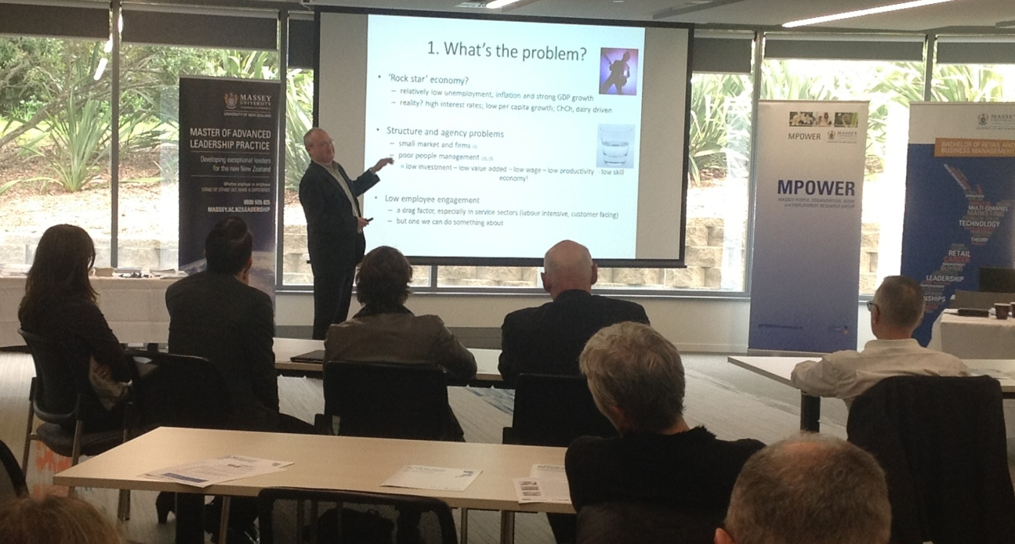
Research presentation 2: Jim Arrowsmith (Massey) on employee engagement in tough times

Research presentation 2: Jim Arrowsmith (Massey) on employee engagement in tough times

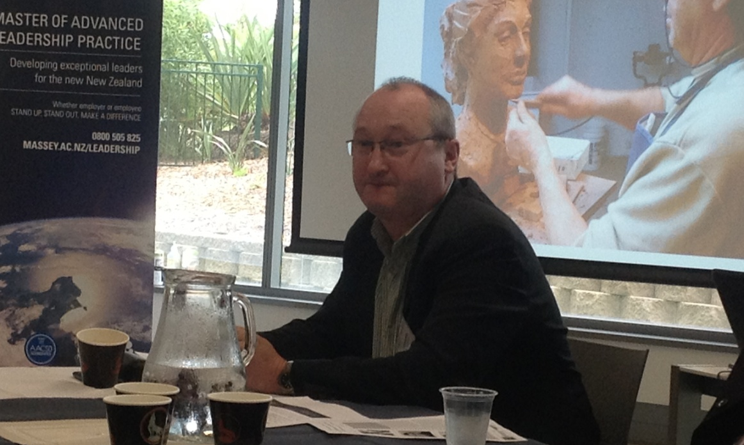
Research presentation 2: Jim Arrowsmith (Massey) on employee engagement in tough times

Research presentation 2: Jim Arrowsmith (Massey) on employee engagement in tough times

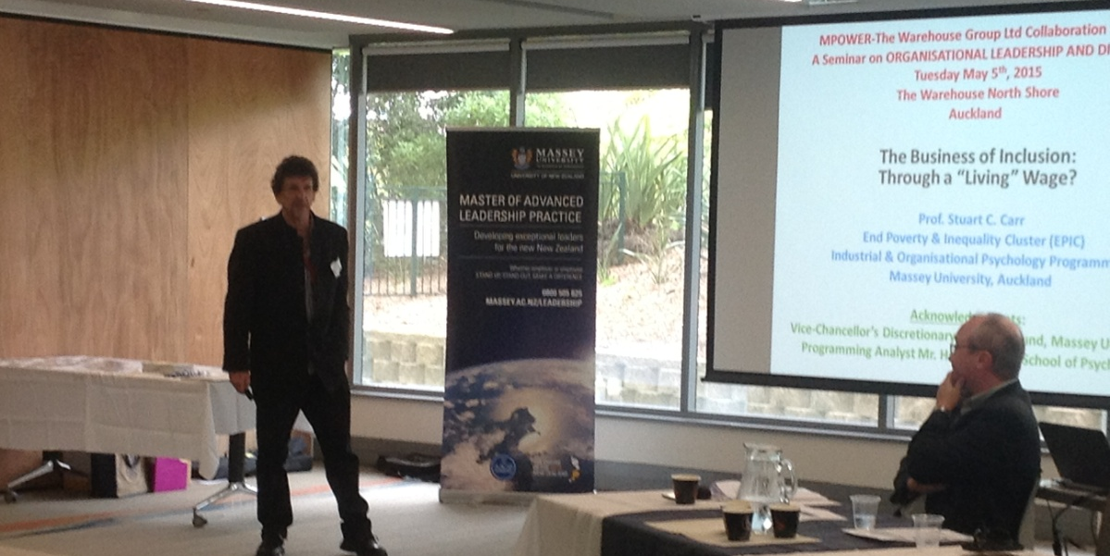
Research presentation 3: Stu Carr (Massey) on business of inclusion and Living Wage

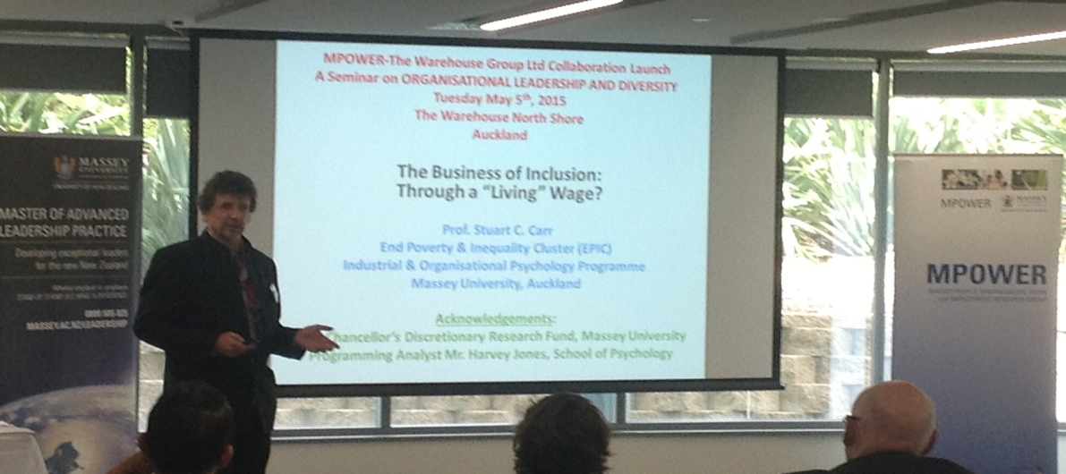
Research presentation 3: Stu Carr (Massey) on business of inclusion and Living Wage

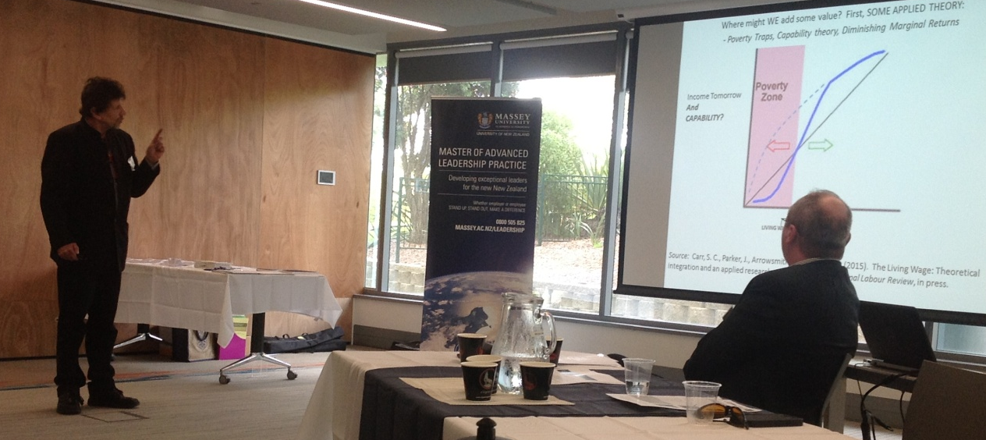
Research presentation 3: Stu Carr (Massey) on business of inclusion and Living Wage

Research presentation 3: Stu Carr (Massey) on business of inclusion and Living Wage

Audience shots

