Jennifer Little

64 9 414 0800 ext 41645

027 453 4562

j.little@massey.ac.nz

news.massey.ac.nz

Wednesday, March 6, 2013

Massey academic in UN think tank on marine health

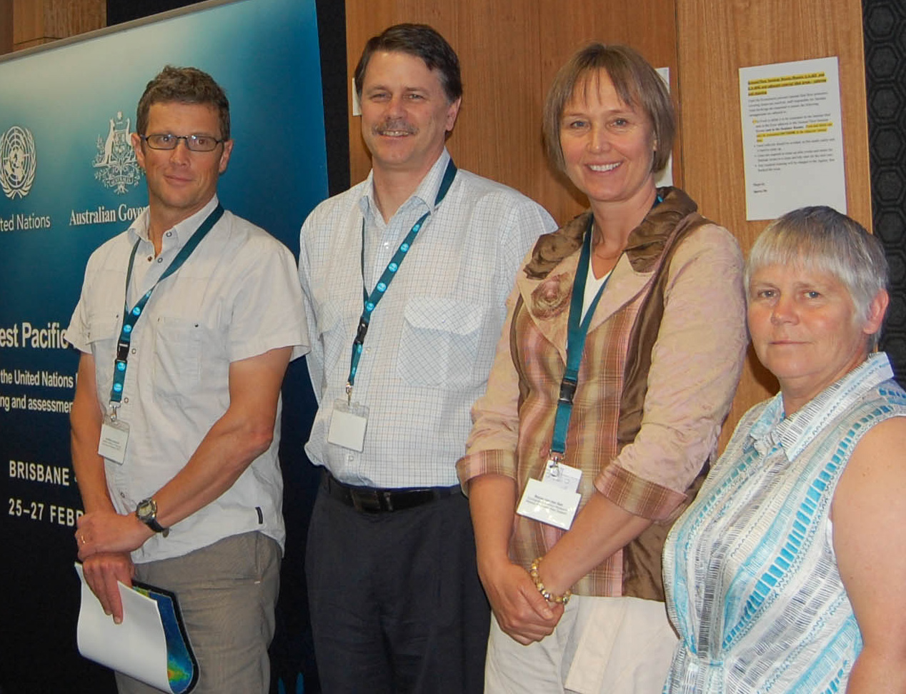
A Massey University economic ecologist has provided expertise in planning a global assessment of the state of the world’s oceans being undertaken by the United Nations.

Associate Professor Marjan van den Belt was part of team of four from New Zealand, including scientists from the National Institute of Water and Atmospheric Research (NIWA). They joined experts for a workshop in Australia to fill in a framework provided by the United Nations for estimating the state of the marine environment in the Pacific, as part of a global study.

“Oceans cover 71 per cent of the earth’s surface and hold 97 per cent of the planet’s water. They are inextricably linked with socio-economic and cultural wellbeing of humanity. Yet the state of this vast and shared resource remains un-assessed to date,” says Dr van den Belt, Director of Ecological Economics Research New Zealand at the Manawatu campus.

The workshop, in Brisbane, was co-hosted by the Australian Government and the New Zealand Ministry for Foreign Affairs and Trade, to coordinate a Pacific Ocean contribution to this global process.

Titled the World Ocean Assessment, it will investigate biodiversity and the impact of oil, mining, shipping and fishing industries. It is envisioned to be ready by the end of 2014 and is to include the input from several hundred experts globally. Experts gathered at the Pacific Oceans workshop identified knowledge gaps, particularly the socio-economic impact and valuation of marine ecosystems and resources.

Dr van den Belt says she hopes the assessment will take an integrated approach using the ecosystem services model, which looks at the benefits humans derive from oceans as well as assessing the impact of human dependence on the Earth’s ecosystems. This approach provides a broad, coherent picture of marine health and human factors contributing to it, against the backdrop of news reports on the decline of marine species and fish populations, increasing acidification of seawater and the threat to marine ecosystems such as coral reefs.

Part of the College of Humanities and Social Sciences, Ecological Economics Research New Zealand focuses on researching and applying models for sustainability at the interface of economics and ecology. It has undertaken projects on Sustainable Pathways in partnership with the Auckland Council, Environment Waikato, and the Greater Wellington Regional Council, as well as a freshwater solutions project funded by the Ministry of Business, Innovation and Employment with iwi, regional council and local authorities and stakeholder in the Manawatu.

Caption: (left to right) Geoffroy Lamarche (NIWA), Peter Harris (Geoscience Australia), Associate Professor Marjan van den Belt (Ecological Economics Research New Zealand at Massey University), and Julie Hall (NIWA).

