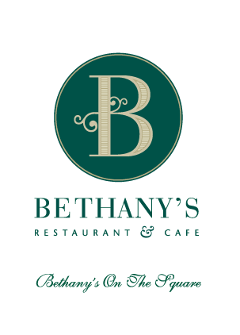

Starters
Chicken Laksa
Chicken strips sautéed, bound in egg noodles and a fragrant laksa stock, coconut cream, topped with julienne of vegetables and toasted crushed cashew nuts.

Seared Scallops (GF)
With a roast capsicum coulis, edamame bean and tomato salsa and a pine nut and kalamata olive crumb.

Braised Short Ribs (GF)
Braised until tender then grilled and glazed with a master stock, soy roasted seeds.
Mains
Beef Fillet (GF)
Served with dauphinoise potatoes, maple roasted pumpkin puree, baby onions, mushroom duxelle, roast cherry tomatoes and watercress, finished with jus and crisp streaky bacon.

Salmon (GF)
Pan seared and served, with gourmet potatoes, cherry tomatoes, feta, artichoke hearts, edamame bean salsa, baby spinach, pine nut and olive crumb, salsa verde and pepper coulis.

Chicken Breast
Wrapped in bacon, gourmet large shell pasta, sweet corn, button mushrooms, red onions, baby spinach, crushed cashew nuts and cherry tomatoes, sundried tomato pesto and apple syrup.

Bethany’s Garden Plate (GF, V)
Beetroot, maple roasted pumpkin puree, Gourmet potatoes, carrots, cherry tomatoes, button mushrooms, artichokes, olives, radish, raisin chutney, edamame bean salsa, soy seeds, kumara chips dukkah and chipotle mayonnaise.
Desserts
Duo of Kapiti Ice Cream
Four scoops, two flavours, cinnamon tuile
Cheesecake of the Day
Your waiter will let you know what today’s special is

Death by Chocolate
A must try by anyone who loves chocolate and if you don’t like chocolate; try it anyway!

Sorbet
Your waiter will let you know what today’s special is
(Gluten & Dairy Free)

