Facilities Management CAMPUS NAME Email-xxxxxxxxx
Campus Address Phone - xxxxxxxxx

Job Safety and Environmental Analysis (JSEA)/Safe Work Method Statement (SWMS)

Part 1: Project and Task Identification
Process: Initiators of JSEAs are responsible for consulting the Project Supervisor, Campus Health & Safety Advisor or other persons directly in charge of the work and other personnel involved in the execution of the task (as appropriate) for input into the JSEA. Other persons may be consulted for technical advice or review of the JSEA to see that proposed measures are effective and workable. The task is to be broken up into steps. For each step, the safety hazards are identified. For each of the hazards identified, corrective action, precautions, equipment are identified to reduce the hazard. All involved in the task must review and sign this JSEA/SWMS form. All JSEA are to be submitted as word document.

Site:
Contact Name |  |  | Job Title | Phone |  |  | Mobile |  |  | Email
JSEA Initiated By |  |  |  |  | Date: |  | Work Order No: |  | Rev No. |  |  | Rev Date
Supervisor Review |  |  |  |  | Date: |  | Location of Work:
 |  |  |  |  |  |  | Building Name:
Massey Review |  |  |  |  | Date: |  | Building Number |  |  |  | Room Number

Help: Describe the work in its entirety and all the steps and phases’ needed to couplet the work. Outline the tasks with detail around hazardous work.

Description Of Work to be Undertaken:

First, identify and assess the risks, then decide the best way to control them by applying the Hierarchy of Control as follows:

LEVEL | CONTROL | DEFINITION
Level 1 | Elimination | Controlling the Hazard at source
Level 2 | Substitution | Replacing one substance or Activity with a less hazardous one
 | Isolation | Separating the hazard from the person
 | Engineering | Installing Guards on machinery
Level 3 | Administration | Implementing policies and procedures for safe work practices
 | Personal Protective Equipment | Use of safety glasses, hardhats, protective clothing, etc.

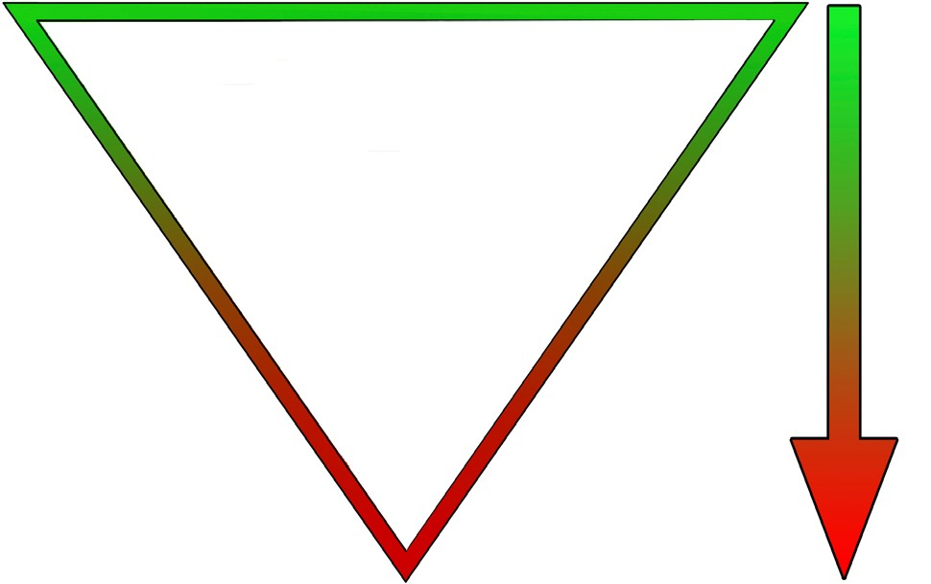
Hierarchy of Controls

Eliminate the hazard
E f f e c t i v e n e s s

Substitute the hazard

Isolate the hazard

Use engineering controls

Use administrative controls

Use PPE

Part 2: Worker Qualifications and Induction Record

Help: List all the qualifications that will be needed to complete the work outlined in the (Description Of Work to be Undertaken) |  |  | Help: General responsibilities around the work site i.e. Maintain adequate house-keeping on site, Reporting of any injuries / incidents to your Project Supervisor. |  | Help: List all training and licenses that may be required for specific tasks i.e. Working at heights. Confined spaces, Asbestos removal.
Personal Qualifications and Experience Required To Carry Out the Works: |  |  | Duties and Responsibilities of Personnel Completing the Task: |  | Formal or Specialized Training or Licenses Required to Complete Work or Operate Specific Plant or Equipment:
Completion of Massey Induction |  |  | Adherence to company's and the Massey University policies and procedures
JSEA/SWMS Sign Off – Your signature below indicates that you have been consulted in development of the JSEA/SWMS and accept and will implement the requirements of the JSEA and control measures
Massey ID No. | Name | Trade |  | Employed By |  | Signature | Date

Part 3: Hazard Analysis, Control and Legislation Worksheet
Help: Highlighted in grey is an example please delete and complete in conjunction with the risk matrix.
Job Safety and Environmental Analysis (JSEA) |  |  | Safe Work Method Statement (SWMS)
Step No. | Process Steps | Potential Hazard(s) | Risk Rating | Hazard Control Measures | New Risk Rating | Action By
 | List the steps needed to do the job in the sequence to be done | Against each step list potential hazards that could cause injury when the job is done |  | For each hazard, identify control measures to eliminate or minimize the risk of injury.
1 | Site Orientation/ Induction
1.1 | Report to client’s reception | Entering restricted areas | 19 | Follow posted signs and go directly to reception | 1 | All
1.2 | Undertake a site induction | Unfamiliarity with emergency procedures | 14 | Listen and ensure you obtain information and site emergency and evacuation procedures | 1 | All
 |  | Unawareness of site specific hazards | 14 | Listen and ensure you obtain information about any and all site hazards | 1 | All
 |  | Unawareness of restricted areas | 18 | Listen and ensure you obtain information about any restricted areas | 1 | All
 |  | Unawareness of other operations or hazardous activities being undertaken on site | 9 | Listen and ensure you obtain information about any other activities being undertaken on site | 5 | All
2 | Claim Work Area
2.1 | Establish safe perimeter | People entering work area | 25 | Controlled by Site Manager | 5 | Site Supervisor
 |  |  |  | Bunting or Caution tape shall define the work area by providing a 3 meter barrier or denying access whichever is more appropriate. | 3 | All

Part 4: Hazard Analysis, Control and Legislation Worksheet - Site modifications, additions or alterations

Help: This part is only to be used for modifications to the above table and must be approved and tracked though the revision section in part:1. Ensure all relevant parties notified of any changes.
Job Safety and Environmental Analysis (JSEA) |  |  |  | Safe Work Method Statement (SWMS)
Step No. | Process Steps  List the steps needed to do the job in the sequence to be done. | Potential Hazard(s)  Against each step list potential hazards that could cause injury when the job is done. | Risk Rating | Hazard Control Measures  For each hazard, identify control measures to eliminate or minimize the risk of injury. | New Risk Rating | Action By

Help: What relevant documentation is applicable? Does the product have a SDS? Does the trade have a code of practice? Is the any relevant legislation to the work?
Reference Detail Applicable Sections of: |  | Legislation |  | Codes Of Practice |  |  | Manufacturer Or Supplier Recommendations
Plant and Equipment to be used for task: |  |  |  |  | Plant, Equipment and Area Safety Inspections:

PPE Requirements for Task:

Dust Mask

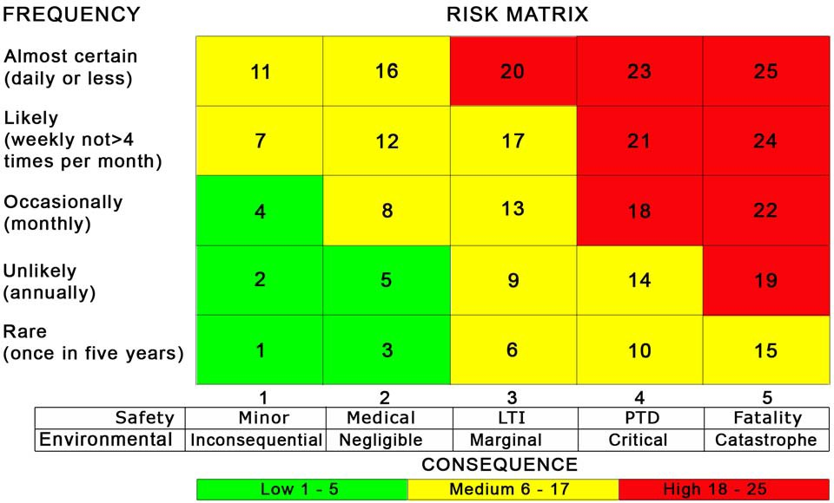
Eye Protection

Gloves

Hearing Protection

Hi Visibility Vests

Safety Boots

Acronyms and Abbreviations:
LTI - Lost Time Injury
PPE - Personal Protection Equipment PTD - Permanent and Total Disability

