MOST
- Course Surveys
Massey Online Survey Tool

MOST is the evaluation tool used to gather feedback from students about the quality of
courses and teaching. The standard Course Survey is compulsory for all taught courses with
more than 10 students and should be conducted at least every 2 years. It takes just a few minutes to initiate; this information sheet explains the basics:

The Course Survey
It has a standard set of questions. There are 10 quantitative and two qualitative questions. Students can also provide comments for all the quantitative questions. The quantitative questions use a 6 point Likert scale of:

Strongly Disagree | Disagree | Tend to Disagree | Tend to Agree | Agree | Strongly Agree

The questions are:
  - Overall, I was satisfied with the quality of the learning experience in this course
  - Feedback on my work helped me learn
  - The content of the course was structured in a way that assisted my learning
  - The workload for this course was reasonable (e.g. for a 15 credit course, 150 hours in total)
  - The online learning environment enhanced my learning
  - The support materials were useful to my learning (e.g., text books, briefs, handouts, study guides, etc.)
  - Assessment requirements were clear
  - This course helped develop my thinking skills (e.g., problem solving, creativity, critical analysis etc.)
  - It was clear how the parts of this course contributed to the learning outcomes (e.g., practical components, lectures or topics, tutorials, studio projects and related activities, online activities, independent work, assessment etc.)
  - My marked assessment was returned within the turnaround time stated in the course outline

  - The aspects of the course that most helped my learning were:
  - The course could be changed in the following ways to improve my learning:

Getting Started
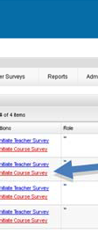
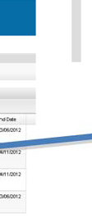
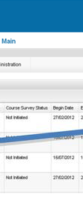
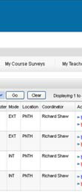
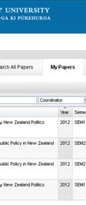
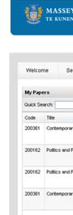
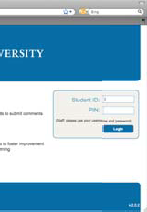
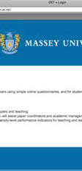
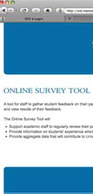
Go to the main MOST page http://most.massey.ac.nz and follow the link to login. The MOST page contains FAQs, important dates and any notices relating to MOST, so it serves as a useful starting point.
Select
Initiate Course Survey
Click My Courses

Enter your usual Massey ID and password here.
Contact ostadmin@massey.ac.nz if you have problems logging in.
y
a

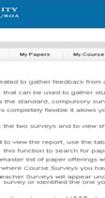
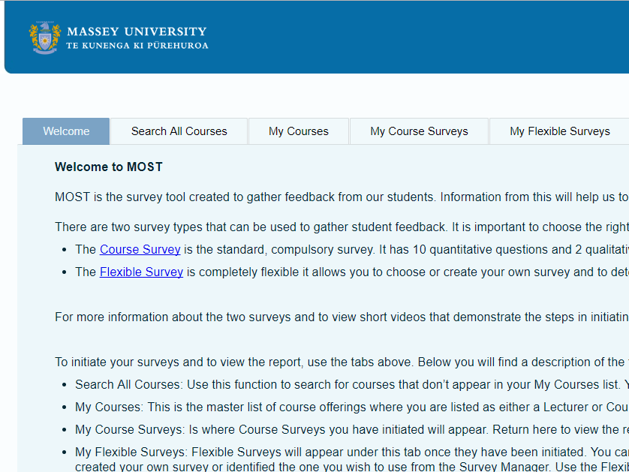

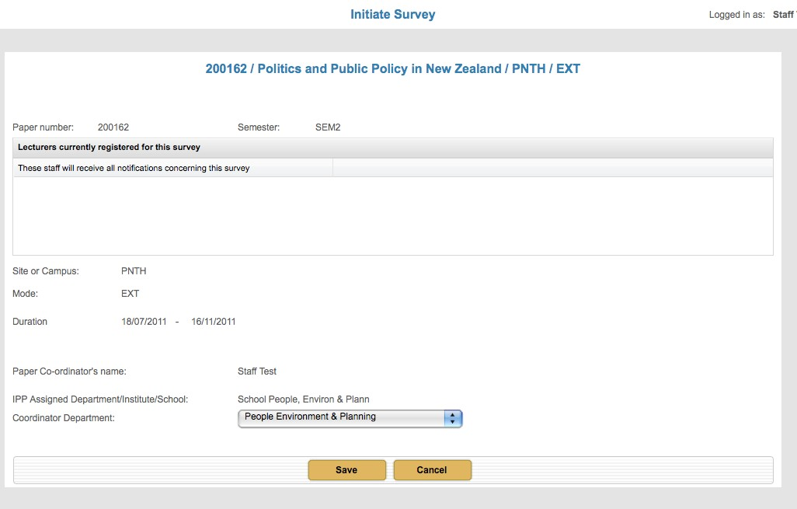
4Check the Semester, Mode and Location of the offering if there is more than one.

Confirm your Department and press SAVE

Becoming the Coordinator
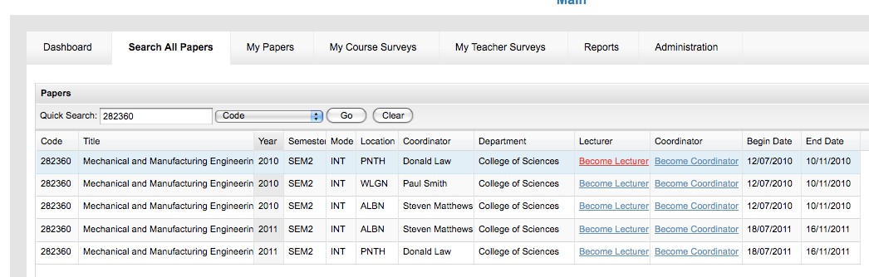
If courses that you coordinate are missing from the list under the My Courses tab you can remedy this by becoming the coordinator. To do this go to the Search All Courses tab and do a Quick Search by code (no dot or space). For the offering that you are coordinating, click on the Become Coordinator link. The coordinator role can only be changed once, so make sure there is no ambiguity.
Becoming the lecturer allows access to the report for teaching staff who aren’t coordinating the course. Follow the same process used to become the coordinator (above) and select the Become Lecturer link. This needs to be done before the survey runs.

You can initiate surveys for more courses by repeating these steps. Once you have initiated a survey it will appear in a list under the My Course Surveys tab. This is where you will return to access the report.

The system will then send email notifications to the course coordinator, any registered lecturers and all enrolled students when the survey becomes available. Response rates are
improved if teachers alert students to the survey and explain the benefits. Do add the link to your STREAM site as well as telling students during classes.

Feedback
When the survey closes and the report is available, Coordinators will be asked to provide feedback to the students. Please take the time to do this as it helps to show students that their time and input is valued. The students are sent a report that contains the percentage agreement total for each question (tend to agree + agree + strongly agree) and the comments from the Coordinator. Students DO NOT see any comments made by their peers. When you respond to students make sure you: use a positive tone, thank them for their participation, identify two or three recurring themes that come from the survey data and give some indication of what you intend to change as a result of their feedback.

Make sure you save a pdf copy of the report for future reference.

Please contact the Course Evaluation Coordinator if you have further questions.

More information is available at http://most.massey.ac.nz

To contact the Course Evaluation Coordinator email ostadmin@massey.ac.nz or phone extn: 83744

