MOST Flexible Surveys Massey Online Survey Tool

Beyond the standard Course Survey, MOST enables teaching staff to take the initiative for their own evaluations, ask the questions that are most relevant to them, time their survey to suit and own the results.

This can include timing a Flexible Survey to occur directly after a specific module, assessment or activity to gather student feedback on that particular aspect of the course; using a Flexible Survey to gather formative feedback, by running it earlier in the semester, enabling the same cohort to benefit from any improvement resulting from their feedback.

Please ensure your survey only covers your own practice, by clearly indicating your name; Flexible Surveys should not be used to gather feedback about another teacher.
Also to ensure optimal response rates for all surveys, please avoid running multiple surveys at the same time on the same cohort thus over-surveying students.
Before you start
Making use of the Flexible Survey tool is more complex than the quick set-up of the Course Survey. Don’t hesitate to contact Ema Alter on 83744 if you need any help or would like to discuss options.

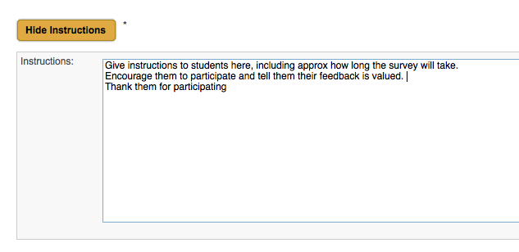
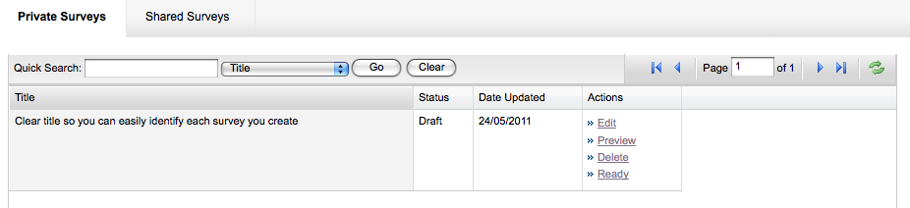
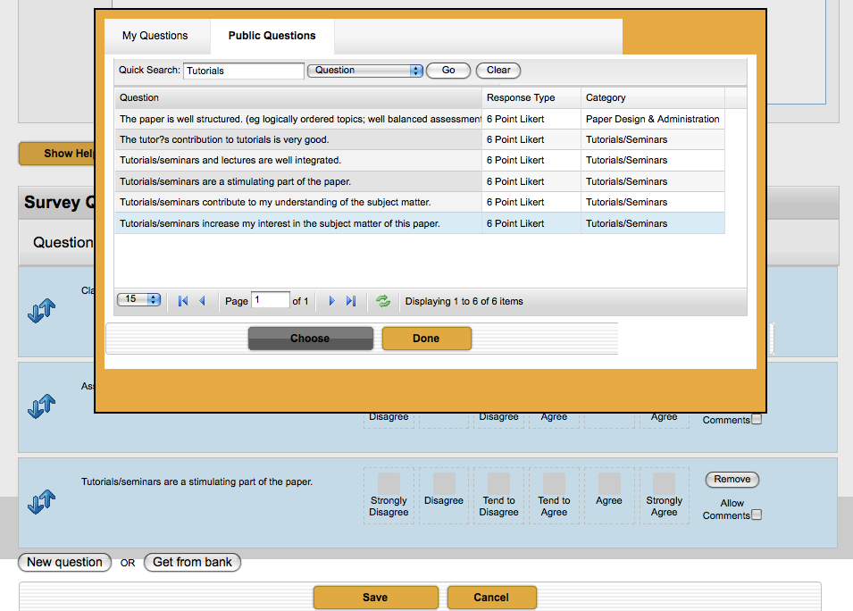
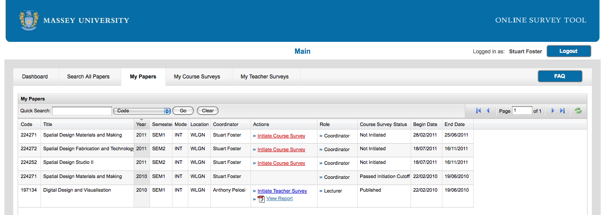
Under the MY FLEXIBLE SURVEYS tab:
Choosing a Survey

There are templates available in the Shared Surveys category of the Survey Manager.
Alternatively you can create your own survey with questions from the question bank and/or your own questions.
Creating a Survey

If you choose to create your own survey follow the link to Create Survey. Start by adding a title and a brief introductory message to students.
Choose your questions from the bank or write your own questions. You can search for key words in questions or search by category to speed up the selection process.
Click on the Allow Comments button for your students to provide comments to support their quantitative responses.
Changing the question order is done by dragging the question to its new position.
Save your survey when you have finished.
In the Survey Manager, mark your new survey as Ready. Now you need to initiate it.
Initiating a Flexible Survey

Whether you intend to use a ready-made survey or one you have created yourself the process of initiating the survey is the same.

Go back to the main MOST screen. Under the Search All Courses tab enter your course code (no dot) into the Quicksearch box and click Go.

For your offering select Become Lecturer.
Once you have assigned yourself to the role of lecturer
you will be able to initiate your Flexible Survey.

Under the My Courses tab select
Initiate Flexible Survey.

You will need to Confirm your Department and select your survey. Surveys you have designed yourself will appear in the Private Surveys list whereas templates and surveys prepared for you by the MOST coordinator appear in the Shared Surveys list. (Make sure you select the right one as some surveys can have similar names).

On the next screen you need to enter the dates you want your survey to run. Please use the correct date format (DD/MM/YYYY) and enter the date you want the survey to go live.
Click in the box below and it will default to 2 weeks before the survey goes offline. You can modify this if you wish. Check the dates before saving.

To confirm your survey is initiated correctly you can go to the My Flexible Surveys tab; it should appear here. You can view the full workflow and preview your questionnaire.

You will return here to view your Flexible Survey report and place feedback for the participating students at the end of the survey cycle.

More information is available at http://most.massey.ac.nz
To contact the Course Evaluation Coordinator email ostadmin@massey.ac.nz or phone extn: 83744

