MOST Course Survey Reports

When your MOST Course Survey closes a report is generated. You will be sent an email to tell you the report is ready. You will need to log into MOST to view the report.

If there were insufficient responses (e.g. less than 5 students) you will be notified. The data from a survey that has insufficient responses can still be viewed, but it is not included in the aggregated results.

The Course Survey report contains a bar graph and a table for the student responses to each quantitative question as well as the comments relating to each question (see Figure 1). All of the student comments from the two qualitative questions also appear at the end of the report.
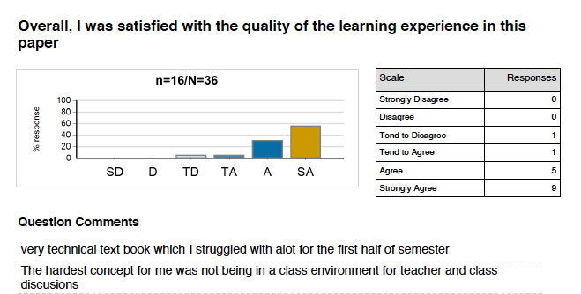
Figure 1. Course Survey report example

These Course Survey reports are available to the coordinators and teachers who opted in. The Head of Department for this paper can also request the report.

The report is initially released to the coordinator to provide feedback for the Student Summary Report. All students enrolled in this course offering will see the student report. When you write your feedback comments, please consider the following:

Do | Don’t
- Keep feedback to students succinct  - Use a positive tone  - Thank students for their responses and time  - Identify the recurring themes or issues from the survey data  - Identify what you intend to change as a result of the feedback | - Provide long-winded justifications  - Retaliate to negative comments  - Get hung up on comments made by only one or two students that differ from the general consensus

Your comments to students show that you have engaged with the process. Students are more likely to respond to future survey requests if they feel their feedback is useful and valued.

The Student Summary Report (see Figure 2) contains only an aggregated percentage of agreement for each question and the coordinator’s comments. Students do not get to see any of the comments made by other students.
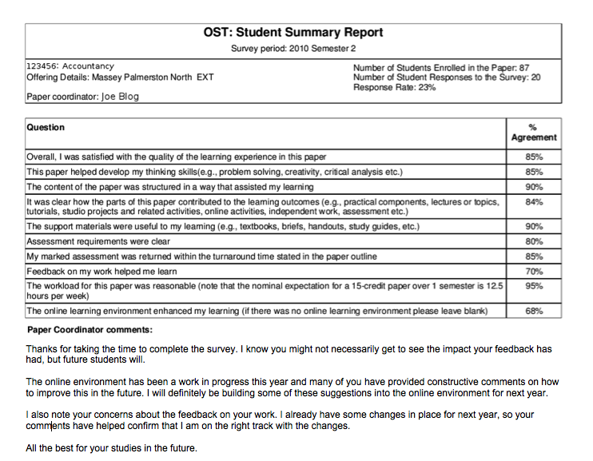

Figure 2. Example of a MOST Student Summary Report

Course Survey reports will remain accessible through MOST for a period of at least two years. We suggest that you download and save your report and print a hard copy for your files. The report can be used in PRPs, promotion applications and teaching portfolios etc.

More information is available at http://most.massey.ac.nz
To contact the Course Evaluation Coordinator email ostadmin@massey.ac.nz

