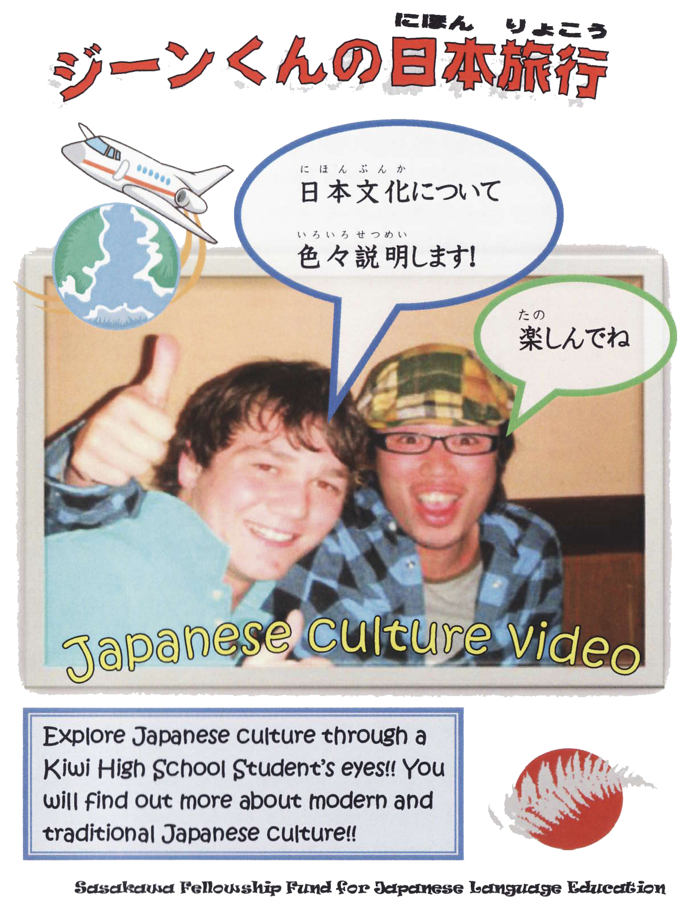

Gene’s Japan Trip

**Contents:**

1. スーパーマーケット Supermarket 5 minutes

2. コンビニ Convenience store 3 minutes

3. カプセル ホテル Capsule Hotel 1 minutes

りょ かん

4. 旅 館 Japanese Inn 3 minutes

いえ

5. 家 House 6 minutes

6. ゲーム センター Game centre 5 minutes

じん じゃ

7. 神 社 Shrine 3 minutes

かい てん ず し

8. 回 転 寿 司 Sushi 2 minutes

しょ うがっ こう

9. 小 学 校 Elementary school 12 minutes

こう こう

10. 高 校 High School 9 minutes

の もの

11. 乗 り 物 Transport 7 minutes

こう きょ

12. 皇 居 The Imperial Palace 3 minutes

あさ くさ

13. 浅 草 Asakusa 4 minutes

とう き ょう

14. 東 京 Tokyo 9 minutes

きょ うと

15. 京 都 Kyoto 9 minutes

うず まさえい が むら

16. 太 秦 映 画 村 Uzumasa movie village 7 minutes

な ら

17. 奈良 Nara 4 minutes

おおさか

18. 大阪 Osaka 3 minutes

こうべ ひ めじ

19. 神 戸と姫路 Kobe and Himeji 8 minutes

くら しき

20. 倉 敷 Kurashiki 4 minutes

ひろしま いち へいわこう えん

21. 広島 壱 (平 和 公 園) Hiroshima Part1 6 minutes

ひろしま に みや じま

22. 広島 弐 （宮 島） Hiroshima Part 2 5 minutes

Introduction: To the Student

Ko Kimura made this DVD, a Japanese teacher from Freiberg High School in Palmerton North. Funded by the Sasakawa Fellowship Fund for Japanese Language Education, through a Short Term Fellowship, Ko and his former student Gene Devonshire traveled to Japan in April of 2008 with the intention of making a video containing language and cultural content of interest to New Zealand students of Japanese.

This guide has been produced as an adjunct to the DVD to help teachers use the resource to develop intercultural competence in their students.

Intercultural language learning integrates language and culture from the beginning. The level of Japanese used in this DVD is suitable for senior students, but younger students will be able to understand some parts of the audio and they will be able to enjoy the cultural experiences shown with some explanations from the teacher.

An exploratory and reflective approach to culture is a focus of intercultural language learning. There are various enquiry approaches teachers could adopt with the material in the DVD.

For example, before showing the video clip, you could find out what prior knowledge your students have about the topic, and what they are interested in finding out about.

Use three large pieces of paper to brainstorm within the class:

1. things you have learnt / already knew about the topic (e.g. school in Japan);

2. things you don’t know yet and want to find out;

3. possible ways to find out the answers to 2.

These can then be displayed in the classroom for the duration of the unit, and referred back to when appropriate.

Showing the video will probably answer some of the questions but could very well generate more. Finding out the answers could be a whole class or small group project, or an individual homework assignment.

Another important aspect of developing intercultural competence is in making connections and comparisons between languages and culture. This means not just comparing what is shown on the video clips with New Zealand, but with the cultures of all students in the class whether they be Korean, Samoan or African, and drawing on knowledge of countries visited on holiday or cultures studied in Social Studies.

The suggestions given for each chapter in this guide are intended to give the teacher ideas as to how they could get students thinking in a more in-depth way about what they have seen, and about how it relates to their own lives.

Depending on the interest of the class and time available, there are various points for discussion and possible follow-up activities. Teachers should select whichever of these they feel are relevant or of interest to the group of students they are teaching at the time.

Jo Barber, for Sasakawa Fellowship Fund

**For more information about this dvd or about the Sasakawa Fellowship Fund, contact: Naomi Collins – n.e.collins@massey.ac.nz**

**1. Supermarket**

a. Gene notices that the fruit in the supermarket is bigger than that sold in supermarkets in New Zealand. Why do you think this is?

b. Why do you think the fruit is so expensive?

c. What was the Japanese name of the meat skewers in the supermarket?

d. On what occasions are these eaten in Japan?

e. Why do you think meat served in this way would be popular in Japan?

f. There are several types of *obentoo* (lunch boxes filled with sushi etc). How do these compare with your lunch box?

g. There is a wide selection of *okashi*. What do you notice about the packaging?

h. Why does Gene not buy the drink he looks at?

i. Find out: What age do you have to be in Japan to: smoke, drink alcohol, get a driver’s license, get married, leave school, get a credit card?

j. How does this differ to New Zealand and other countries?

k. What impact do you think a change to this law would have on Japanese society?

**2. Convenience Store**

a. Where does the word come from? Is the name appropriate?

b. List some of the things that can be found in the convenience store. Listen to the voiceover a few times if necessary to complete the list.

c. What other things can you do in the convenience store using the machines?

d. How does the convenience store compare to the Japanese supermarket?

e. What would be the nearest thing that you have to a  where you live?

f. If you can read Japanese script, pause the video at various times to read the labels and prices.

**3. Capsule Hotel**

a. What kind of people would use a capsule hotel?

b. What else is offered here? Look at the red word at the top of the sign. 

c. What are the advantages of this type of accommodation?

d. Disadvantages?

e. What does each capsule include?

f. Do you think a capsule hotel would be popular with New Zealanders?Give your reasons.

**4. Japanese Inn**

a. Who would stay at a *ryokan*?

b. How does it differ to the capsule hotel?

c. Explain what the process is for using the bath at a *ryokan*.

h. What is usually included in the room at a *ryokan*?

i. **Research:** Find out what a typical *ryokan* in Japan costs. What is included in the price? How does it compare to the cost of the capsule hotel?

j. What other types of accommodation are available in Japan?

k. If your class went to Japan, what type of accommodation would you stay in? Why?

**5. House**

a. Gene demonstrates the correct way to put your shoes in the entrance hall. Why do you think this is important?

b. Poll your class. How many people don’t wear shoes inside their house?

c. Have you been to other places in New Zealand where shoes are not worn inside?

d. Gene, as guest, is seated in front of the *tokonoma* (alcove). His host answers Gene’s questions about the objects. Find pictures of other *tokonoma* and compare them to this one. Do they all have the same items?

e. Gene seems quite impressed with the automated toilet in the Japanese house. What could be a problem with this type of toilet?

f. What are the advantages of sleeping on futon?

g. List any items in this house that you don’t have in your house at home. Which of these items would you like to have in your house?

h. How do you think the power usage in this house compares to an average New Zealand house? Why do you think this?

**6. Game centre**

a. Which games are different to the ones you can play here in NZ?

b. How much time do you spend in game centres?

c. Find out what Japanese teenagers do in their spare time (as well as / apart from game centres!) How does this differ to what you and your friends do in the weekends?

d. What is on the top floor of the game centre? Why are these games restricted?

e. Find out about *pachinko*.

For more information about Japanese teenagers and their lifestyles, visit this site: <http://factsanddetails.com/japan.php?itemid=622&catid=18>

**7. Shrine**

a. Find various pictures of people carrying a *mikoshi* during a festival. What are the common elements to all of the pictures? Which things are different?

b. Make a paper model of a *mikoshi.* Free download from this site: <http://www.yamaha-motor.co.jp/global/entertainment/papercraft/seasons/index.html>

c. Discuss superstitions – ringing the bell, clapping twice, *omikuji* and *ema* boards. What superstitions do we follow in NZ and in other cultures that you know of?

d. Find out which festivals or family occasions are celebrated at shrines. How does your family celebrate these occasions?

e. Find out more about the *Shinto* religion. How does it differ to Buddhism or other religions?

f. Compare the shrine shown here to a Buddhist temple. How can you tell the difference between the two?

Chapters 13, 15, 17 and 18 of this DVD contain more footage of shrines and / or temples. For more information about Japanese religion, visit this site: <http://factsanddetails.com/japan.php>

**8. Sushi**

a. Describe the process for ordering *sushi.*

b. Why are there two different “trains”?

c. Has anybody in the class ever experienced “*kaiten sushi*?” Ask them to tell the class about it.

d. Is this a convenient way to eat / serve the food? Would it work for different types of food (e.g. hamburgers)? Why / why not?

e. Do you know of any other interesting methods of serving Japanese food? *(Teppanyaki, sukiyaki)*

f. How does this compare to how food is served in your favourite restaurant? At home?

g. Why do you think Japanese people eat so much rice and fish?

*Try making sushi in class. All ingredients can be prepared beforehand and brought to school by the students. Since sushi doesn’t require cooking, it can be made in a normal classroom. Recipes and how-to videos can be found easily on the internet.*

**9. Elementary School**

a. Make a table listing the differences between primary schools in Japan and in NZ.

b. Which things are the same in both countries’ schools?

c. Explain what the students have for lunch at school. What is the procedure for eating / serving lunch?

d. What are the advantages / disadvantages of school lunches?

e. Do you think this should be done in your school in NZ? If so, what would be on the menu? Divide into groups and come up with a menu for one / five days which will appeal to children your age and also meet the approval of the principal and B.o.T.

f. The cleaning of the school is done in a very efficient way with all students being involved. Do you think this is a good system? Would it work in your school?

g. What do you notice about the outside playground?

h. What do you think life would be like as a primary school student in Japan?

**10. High School**

a. What do you think about the school uniforms, and the way they are worn? How does this compare to your school?

b. What do you notice about the way the classroom is set out?

c. How does the high school compare to the elementary school?

d. What are the different options for lunch?

e. What do you notice about the *taiko* drumming in terms of performance?

f. How does it differ from the next performance (the festival dance)?

Find out the following;

g. What age is compulsory schooling in Japan?

h. What are some of the school rules?

i. What subjects do most high school students study?

j. When do they get to choose the subjects they can study?

k. How hard do most students work?

l. Would you like to attend high school in Japan? Why / why not?

**11. Transport**

a. Japan is famous for inventing and manufacturing cars, yet Japanese people spend a lot of time on public transport. Why do you think this is necessary?

b. List the features of the following types of transport: monorail, Train Subway, Bullet train, Bus.

c. When would you use each one? (Everyday transport to work/school, long distance travel etc.)

d. How does using a bus differ from the rail transport?

e. Do you think you would be able to find your way around Japan using public transport?

f. Find out what happens in Japan during rush hour at train stations.

g. Find out about car parks in Japan. How do these work, and why are they so different to what we have in NZ?

h. Being an island nation, Japan has many bridges between islands and even a tunnel that goes under the sea between two of the islands. See what you can find out about them.

**12. The Imperial Palace**

a. This is where the Emperor lives. See what you can find out about the Emperor and his family.

b. What does the Emperor actually do? Is his role more like the Prime Minister, or the Queen?

c. How do ordinary Japanese people feel about the Emperor and his family?

d. How does this compare to the British royal family?

Find out more about the Imperial Palace at <http://www.japan-guide.com/e/e3017.html>

Follow this link to a youtube video of the Emperor’s birthday, with thousands of people at the Imperial Palace. <http://www.youtube.com/watch?v=2oactno6qks&feature=related>

The imperial flag:  
  
 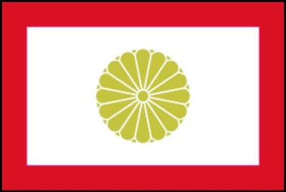

**13. Asakusa**

Pause the video on each of the souvenir shops, and let students have a good look at what is sold, and the prices etc. More information can be found at this site: <http://www.tokyo-bazaar.com/asakusa/>

Compare the experience at the temple with 7. Shrine

a. What do you do differently in a temple to a shrine?

b. Find out about how Buddhism is observed in Japan.

c. There are a lot of school students in *Asakusa* on a school trip. Why would they choose to go to *Asakusa*? Is it a place you would visit if you went to Japan?

**14. Tokyo**

a. Travelling on Tokyo’s *Yamanote* train line you can visit all of the places shown in this video. Make notes on the following places and after viewing the video have a discussion in your class as to which places you would visit if you had a day to spend in Tokyo: *Akihabara, Ginza, Shinjuku, Harajuku, Shibuya*.

b. Look at a floor guide from a department store (follow the link to *mitsukoshi* department store) and spend time reading the *katakana* and *kanji*. Which items are grouped together? Would we expect to find this kind of grouping in New Zealand?

<http://www.mitsukoshi.co.jp/store/1010/floorguide.html>

c. Currency conversion – find out exactly how much some of the food items shown in the video would be in $NZ.

d. *Harajuku* girls – made famous by a song written by Gwen Stefani (you will find many youtube videos).

e. Find out more about traditional Japanese weddings. How do they differ from weddings you have been to? How are they similar? Do all Japanese weddings follow the same formula?

The statue of *hachikö* is shown at the end of the video. Follow the link to find out about the story of *hachikö:* <http://en.wikipedia.org/wiki/hachikö>

**15. Kyoto**

*Kyoto*, the ancient capital of Japan, is famous for its temples and shrines. Gene visits some of these famous places today.

a**. Kinkakuji - the Golden pavillion**. *Kinkakuji* has an interesting history. See what you can find out about it.

b**. Ryooanji**. What do you think intrigues Japanese people about the rock garden? What do you think of it? Do you think this kind of garden would be popular in New Zealand?

c. Do you think Japanese people are more or less superstitious than the average New Zealander? Give examples from the video.

d. Summarise the similarities and differences between temples and shrines.

e. *Kyoto* is a popular destination for tourists and students from other cities on school trips. Why do you think it would be a popular place to visit?

f. If your class was in *Kyoto* and could only visit two of these places, which ones would you choose? Why?

**16. Uzumasa Movie Village**

Find out about the history of samurai: <http://www.japan-guide.com/e/e2127.html>

a. What are ninja? How do they differ from samurai?

**17. Nara**

a. *Todaiji* is a very famous temple. What makes it different to other temples you have seen?

b. Recycling is important in Japan. Pause on the shot of the various recycling bins so students can read the labels. Why do you think Japanese people have embraced recycling so much?

Further information about recycling in Japan: <http://www.city.yokohama.jp/me/pcpb/foreign/dashikata/e.html>

**18. Osaka**

a. What is *Osaka* famous for?

b. What do you think of the food on display? How does it differ to what you would normally eat?

c. How does the *shootengai* (shopping arcade) differ to the malls we have in New Zealand?

d. Note the displays of plastic food or pictures on menus. What is the advantage of this system?

**19. Kobe and Himeji**

a. Why are the people dancing?

b. What do you notice about the way various people are dressed?

c. How does *Kobe* differ to the other places you have seen?

d. What do you think the lifestyle would be like for someone living in *Kobe* compared to *Tokyo*?

e. *Himeji* castle. Why / for whom was this castle built?

f. Give two reasons why people might visit this castle.

g. Compare *himeji* castle to a famous site in your town. <http://www.larnachcastle.co.nz/index.pasp> (Larnach castle Dunedin)

**20. Kurashiki**

a. *Kurashiki* is sister city to Christchurch. What do the two cities have in common?

b. Find out exactly how *tatami* mats are made. Discuss in groups the advantages and disadvantages of *tatami* compared to wooden floors or carpet.

**21. Hiroshima part 1**

Read the story of Sadako and make origami cranes: <http://www.sasakawa.co.nz/cranes_for_peace.htm>

Related resources for in-depth cross-curricular study: <http://www.webenglishteacher.com/coerr.html>

Find out more about the atomic bomb, its effects, or the events during the war which led up to the dropping of this bomb.

**22. Hiroshima part 2**

Try making *okonomiyaki* in small groups.

For a recipe for *okonomiyaki* go to this site (osaka style but easier than hiroshima style, and contains pictures):

http://visualrecipes.com/recipe-details/recipe_id/120/ okonomiyaki-aka-Japanese-pizza/