Southland Interaction Afternoon

1 July 2014

Organisation of the Interaction Afternoon

Comp Finish~1.20 | Lunch
1.20-1.30 | Explanation of the afternoon as a group.
1.30-2.15 | Practice Interactions  Level 1 in library with Sime先生  Level 2 in 48P with Thomson先生  Level 3 in 47P with Sasaki先生
2.15-2.45 | Record Final Interactions
2.50pm at latest | JHC students depart  SGHS students depart

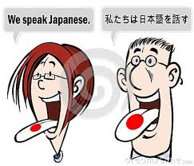

YEAR 11 JAPANESE 1.3 INTERACTION
You are going to meet with a student from another school. You are to introduce yourselves to each other in Japanese and find out as much as possible about each other.
- You could start with私は（Name）です。はじめまして。どうぞよろしく。
- If you want to ask them the same question that they have asked you, use: あなたは or ‘their name’ さんは？
- If you don’t understand the question sayもういちど いってください。OR
すみません、わかりません。
- Ideas of things you could discuss are written below

Personal Information | Name | Age | Birthday
School | Which one | Year Level | Subjects Studied  (good at, bad at, like, dislike)
Nationality | Live | Born | Languages Spoken
Hobbies | What | Where | When
Sports | What | Where | When
Weekend | What | Where | When
Family | How Many | Siblings | Pets
Today’s Meals | Breakfast | Lunch | Dinner

Possible Questions
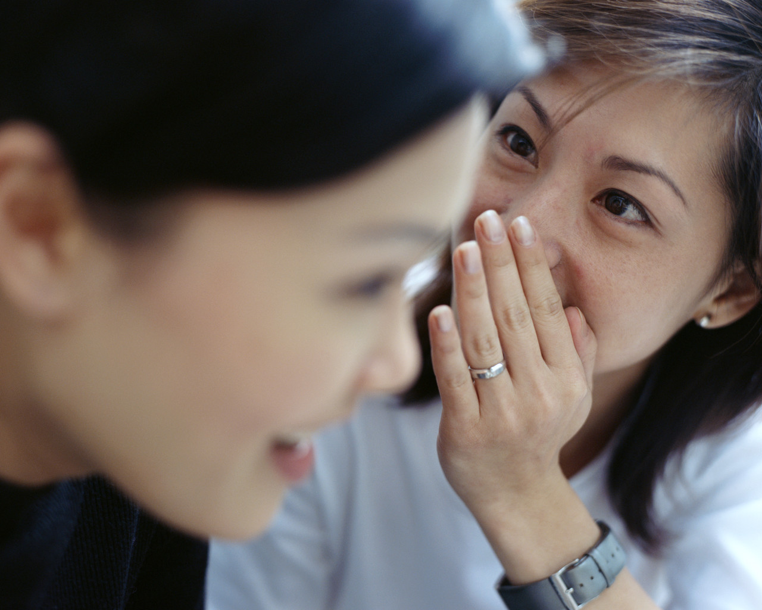
- お名前は何ですか。(What is your name?)
- 何才ですか。(How old are you?)
- おたんじょう日はいつですか。(When is your birthday?)
- どの学校に行っていますか。(Which school do you go to?)
Or simply: ‘Name of school’ に行っていますね。
(You go to …..school don’t you)
- 何年生ですか。(What year student are you?)
- 学校で何をべんきょうしますか。(What do you study at school?)
- 何がすきですか。(What do you like?)
- 何がとくいですか(What are you good at?)
- 何がきらいですか。(What do you dislike?)
- 何がにがてですか(What are you bad at?)
- 何人ですか。(What nationality are you?)
- どこにすんでいますか。(Where do you live?)
- どこでうまれましたか。(Where were you born?)
- 何語をはなしますか。(What languages do you speak?)
- しゅみは何ですか(What are your hobbies?)
- どこでしますか。(Where do you do it/them?)
- いつしますか。(When do you do it/them?)
- 何のスポーツをしますか。(What sports do you do?)
- どこでしますか。(Where do you do it/them?)
- いつしますか。(When do you do it/them?)
- ひまな時に何をしますか。(What do you do in your free time?)
- しゅうまつに何をしますか。(What do you do in the weekend?)
- どこでしますか。(Where will you do it?)
- いつしますか。(When will you do it)
- 何人かぞくですか。(How many people in your family?)
- 何人きょうだいですか。(How many siblings including yourself?)
- ペットがいますか。(Do you have any pets?)
- あさごはんに何をたべましたか。(What did you have for breakfast?)
- ひるごはんに何をたべましたか。(What did you have for lunch?)
- ばんごはんに何をたべますか。(What will you have for tea?)

YEAR 12 JAPANESE 2.3 INTERACTION
The students from SBHS, SGHS & JHC will meet on the afternoon of the speech competition in July. You are to discuss with a student from another school about Teenage Health & Lifestyles.
Talk about your current lifestyle. You could, for example, discuss:
- part time jobs
- homework
- boyfriend/girlfriends
- cars/driving
- how you use your leisure time and why
- what exercise you currently do and why (Do you think it is enough?)
- your diet (eating habits)
- good and bad habits
- You will need to make sure that you justify any ideas and opinions that you share. Reason ので opinion と 思う /idea
Here are some possible questions to help you get started:
- アルバイトをしていますか。(Do you do a part-time job?)
- アルバイトがしたいですか。(Do you want a part-time job?)
- しごとがほしいですか。(Do you want work?)
- まいしゅう何時間ぐらいはたらきますか。
(About how many hours each week do you work?)
- どこでアルバイトをしますか。
(Where do you do your part-time job?)
- アルバイトでどんなことをしますか。
(What sort of things do you do at your part-time job?)
- いつ、しゅくだいをすることができますか。
(When are you able to do your homework?)
- どのぐらいしゅくだいをしますか・べんきょうしますか。
(About how long do you do your homework/study for?
- ガールフレンド・ボーイフレンドがいますか。
(Do you have a girlfriend/boyfriend?)

- くるまをうんてんすることができますか。
(Can you drive a car?)
- うんてんめんきょ(driver’s licence)を、もっていますか。
(Do you have a driver’s licence?)
- 車をもっていますか。
(Do you have a car?)
- ひまなときに何をしますか。
(What do you do in your free time?)
- ひまなときにうんどうをしますか。
(Do you do exercise in your free time?)
- おとなは一日に三十分ぐらいうんどうをした方がいいですね。あなたはどうですか。
(Adults should exercise for about 30 minutes per day, shouldn’t they? How about you?)
- あなたの一番すきな食べ物は何ですか。
(What is your favourite food?)
- よく、からだによくない食べ物を食べますか。
(Do you often eat food which is bad for you? {Not good for your body?})
- わしょくとようしょくとではどちらのがからだにいいと思いますか。どうして（なぜ）ですか。
(Which do you think is better for you, Western food or Japanese food? Why?)

A summary of the ideas of some things you could discuss are written in the chart below:
Part time job | Do? | Want? | Hours? | Where? | Tasks?
Homework | When can you do it? | How much ?
Girlfriend/  boyfriend | Have?
Car | Can you drive? | Driver’s licence? | Have a car?
Leisure Time | What? | Why?
Exercise | Do? | 30mins?
Diet | Favourite Food? | Bad Food? | Western versus Japanese?

YEAR 13 JAPANESE 3.3 INTERACTION

Regions of Japan
The students from SBHS, SGHS & JHC will meet on the afternoon of the speech competition in July. You are to discuss with a student from another school about what region(s) of Japan you would like to visit in the future and why.
During your discussion you could talk about things such as:
- What you’ve learnt about the different regions of Japan
- Your perceptions of these regions based on what you’ve learnt.
- Places that you particularly want to go to and why.
- Thoughts on similarities and differences between Japan and New Zealand.
Can your partner change your perspective about where to travel to?

POSSIBLE QUESTIONS

- Have you ever been to Japan?
日本に行ったことがありますか。
- Which regions of Japan did you visit?
どの地方に行きましたか。
- Which region(s) of Japan would you like to visit in the future?
しょうらいに、日本の地方のなかでどこにりょこうしたいと思っていますか。
- Why would you like to go there?
どうして REGION に りょこうしたいんです か。
- What is the climate like?
REGIONのきこうはどうですか。
- What is ____famous for?
REGIONは何で有名ですか。
- What would you do if you went there?
REGIONに行ったら、何をけいけんしたいと思っていますか。
- What sort of people might like this region?
どんな人がこの地方が好きでしょうか。
- Are there any similar regions in NZ to …?
REGION はニュージーランドの地方とにている所はありますか。

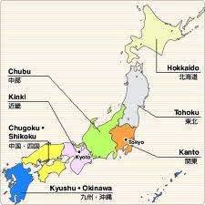

Southland Interschool Japanese Speech Competition 2014:
Instructions for Participants

Year 7/8 Role Play (only 2 students)
Length: Minimum 30 seconds
Topic: Free

Year 9 Role Play (only 2 students)
Length: Minimum 30 seconds
Topic: Free

Year 10 Spoken presentation
Length: One minute
Topic: Self Introduction （じこしょうかい）

Describe your family as though you are introducing yourself to a group of Japanese people. Include details of at least two family members as well as yourself. Describe such things as names, ages, occupation/ school, how you get to school, hobbies and subjects studied. Be familiar with all the family names.

Be prepared to answer two questions in Japanese relating to the topic after you have finished your Self Introduction.

Year 11 Spoken presentation
Length One minute
Topic: My holiday

Describe a holiday you have recently had (it may be imaginary) or talk about where you normally go on holiday. Describe what you can do at this place, how you get there and what you like about it. You could also include details about who you go on holiday with.

Make sure that you use a range of language and language features that are fit for the purpose and audience.

Be prepared to answer two questions in Japanese relating to the topic after you have finished.
Year 12 Spoken presentation
Length: Two minutes
Topic: A town and typical New Zealand housing

A group of exchange students from Japan is visiting your school. Give a spoken presentation in which you introduce them to a NZ town and typical New Zealand housing and mention where you might take the visiting students and what you could show them. Your spoken presentation could include:

- explain key features of NZ houses and your town
- express your ideas and opinions about the features
- justify your selection of a feature or features as not to be missed.
- give a brief history/description of your town
- explain local customs and practices
- show knowledge of cultural aspects of Japan in order to make comparisons and show insight, where

Make sure that you select and use a range of language and language features that are fit for the purpose and audience.

Be prepared to answer two questions in Japanese relating to the topic after you have finished.

Year 13 Speech
Length: Two – Three minutes
Topic: Open

Your task is to give a clear spoken presentation that communicates a critical response to stimulus material.

Possible topics are:
- Positively Different – explain a Japanese Cultural practice/trend
- Reviewing a Cultural Activity which you have have participated in

Your review must be more than a description – “a critical response” will include analysis, interpretation or evaluation.

Whether you are expressing your own view point or supporting or challenging the ideas or opinions of others, explain and justify your thinking.

Make sure that you select and use a range of language and language features that are fit for the purpose of the presentation and audience.

Be prepared to answer two questions in Japanese relating to the topic after you have finished.

Southland Interaction Afternoon: Invitation Letter to schools

15 June 2014

Dear Japanese Teachers

Southland Interschool Japanese Speech Competition

This year the Southland Interschool Japanese Speech Competition will be held in Week 9 of Term 2. The details are as follows:

Date: Tuesday, 1 July 2014

Time: 9.00 am – 12.30 pm approximately

Location: Southland Boys’ High School

Topics: The topics and instructions for students are attached.

Cue cards: Cue cards may be used (in English or Japanese) for quick reference, but they must in no way dominate the presentation.

Questions: Year 10-13 students will be asked two questions in Japanese immediately following their speech. A judge or a questioner will make them up on the spot.

Entries: Each school may enter 3 students in each of the Year 10-13 categories and 3 pairs may be entered for the Year 7/8 section and 3 for the Year 9 section. (Only if schools have two large classes at any year level, they may enter four in that category.)

Names of entrants must be e-mailed to Midori Sasaki at Southland Boys’ High School (midori.sasaki@sbhs.school.nz) by Tuesday 24 June 2014.

From a suggestion in the 2012 debrief, we are asking schools to supply photos of the entrants to help the judges. Please send with your entries.

Entries after this date will not be accepted.

Judging: The same as last year, there will be 3 sections. However this year the combinations will be:
- Year 7&8 and Year 9
- Year 10 & 11
- Year 12 & 13

This will give us time to do activities (water calligraphy, chopstick races, region discussion, puzzles, etc) with the students between the speech contest and the prize-giving. It also allows us more time at the prize-giving to hear the winners’ speeches. The students will be able to see what the next section involves by seeing the winners present their speeches.

Each section will hopefully have one judge and one questioner, who will prepare and ask questions to all students in the section. (If we are lacking in Japanese speakers a judge may be both the judge and questioner).

We would appreciate the assistance of all teachers with various jobs on the day. Please indicate if you will be available to help.

The students will be judged holistically on their speech and the judge will be listening for Information, Accuracy, Variety of language, Fluency, Pronunciation, Timing, Audience appeal (i.e. eye contact, confidence, expression, props) and the ability to comprehend and answer questions.

Time Limit: It is important to keep to the time limit given. Year 10 & 11 students will only be marked up to the 1 minute & 10 seconds mark. Likewise Year 12 students will only be marked up to the 2 minute & 20 seconds mark and Year 13 students will only be marked up to the 3 minute & 30 seconds mark.

Audience Appeal: We would like to encourage the students to work on their “Audience Appeal” with the use of props, expressions, etc. One possibility may be the use of a power point presentation to accompany their speech.

Audience: Family members are more than welcome to come and listen.
Other students of Japanese are also welcome. Please indicate how many ‘extras’ you will be bringing on the day for seating purposes.

Morning Tea: we will have water available for the judges and not stop for an official morning tea break, as it often holds up our proceedings. Teachers are of course, welcome to go to the staffroom and help themselves to a hot drink should they desire one.

Prizes: Each student will receive a Certificate of Participation.
Students who get 1st place will receive trophies. The prizes will be donated by the Sasakawa Fellowship Fund, the Japan Foundation, and local organisations. We are very grateful to these organizations for their continued support. Since we have 3 sections now, we will have 3 Mayoral prizes, one for each of the sections.

Just like last year we will hold an Interaction Afternoon for Year 11-13 students on the afternoon of the Speech Contest to give them an opportunity to complete an interaction with students from other schools. Some sushi and juice will be provided for the senior students, thanks to the Sasakawa Foundation, between the Speech Competition and the start of the Interaction afternoon at 1.20pm

If you have any questions please don’t hesitate to contact me at school or by email.

I look forward to seeing you and your students on Tuesday 1 July 2014.

Yours faithfully

Midori Sasaki
HOD Languages
Southland Boys’ High School

Southland Interaction Afternoon: Prizes 2014

Year | Place | Prize
9 | 1st | Language Perfect Voucher + Pencil Case + Kendama (boy)  Language Perfect Voucher + Ayatori Book (girl)
 | 2nd | Kendama
 | 3rd | Socks (girls)
10 | 1st | Language Perfect Voucher + Calligraphy set
 | 2nd | Photo Album, Kimono Tissues & Magnet (Girl)
 | 3rd | chopsticks + kite (boy)
11 | 1st | Language Perfect Voucher + Children’s Book
 | 2nd | Towel
 | 3rd | Chopsticks, magnets & Bubble Gum Pack
12 | 1st | Language Perfect Voucher + A Geek in Japan
 | 2nd | A Geek in Japan + Geisha DVD
 | 3rd | A Geek in Japan
13 | 1st | $50 Bonsai Meal Voucher + Lonely Planet
 | 2nd | $50 Bonsai Meal Voucher
 | 3^{rd=} | Berlitz Japanese Cd & Sushi Magnets (Girl)  Kamikaze DVD & karuta (Boy)
Y7 - 13 | Participation | 2 x Japanese Bubble Gum & head band

