Day 1 | Thursday February 19
9.00 - 10.00 | Coffee and Registration (9.00 - 9.30am)  Addresses from Honorary Guests, Miles and Janet King (Kingsmeade Cheeses) and Minister Nathan Guy (9.30 - 9.45)
9.45 - 10.45 | Plenary 1: Lucy Cruickshank (2014 Nuffield Scholar)  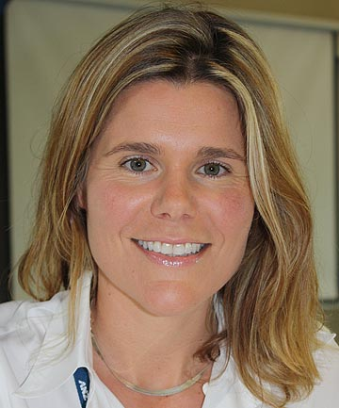  ‘A Business Plan for NZ Sheep Dairying’
10.45 - 11.00 | Morning coffee
11.00 - 1.00 | Workshop 1: Customers, markets and products (Chair: Lucy Cruickshank)  Participants include: Scottie Chapman and Nick Hammond (SLC Group), Keith Neylon (Blue River), James Clairmont (Waiheke Cheese), Joannie Williams (Origin Earth)
1.00 - 1.45 | Lunch and Exploratorium
1.45 - 2.45 | Plenary 2: John Ryrie (Chair UK Sheep Dairy Association)  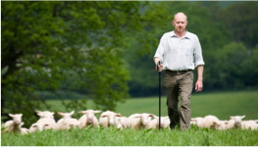  ‘Sheep Dairying in a global Context (draft title)’
2.45 - 3.00 | Afternoon coffee
3.00 - 5.00 | Workshop 2: Manufacturing, Process and Regulation (Chair: Richard Archer, Massey) Participants include: Rod Finch (Alliance Sheep Milk), Miranda Fraser, Carla Hutchinson and Rebecca Tayler (MPI)
6.30 | Pre-dinner refreshments and Dinner at Wharerata  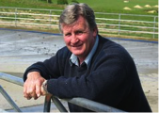  Speaker: Honorary Guest Keith Neylon (Blue River Dairy)
Day 2 | Friday February 20
8.30 - 10.30 | Workshop 3: Farm operations and management (Chair: Sam Peterson, Massey) Participants include: William McMillan (Consultant), Ken Geenty (Consultant), Guy Trafford (Lincoln University), Nick Lyttle (Mineral Systems Ltd), Andy and Kat Gunson (GXsim), Brian Beuke (Neudorf)
10.30 - 11.00 | Tea and Exploratorium
11.00 - 1.00 | Workshop 4. Genetics (Chair: Jock Allison)  Participants include: Nicolas Lopez-Villalobos (Massey), Suzanne Rowe (AgResearch), Graham Alder (Beef and Lamb),
1.00 - 1.30 | Lunch and Exploratorium
2.00 - 4.00 | Workshop 5. Industry Structure (Chair: Craig Prichard, Massey), Participants include: Andrew Macpherson (Landcorp), Bill Jamieson (Entrepreneur), Hamish Gow and Elena Garnevska (Massey)
4.00 - 4.15 | Final remarks Honorary Guest William Konui (Waituhi Kuratau Trust)

Draft Programme

