## What is the Salmonella study?

Massey University, in collaboration with dairy industry stakeholders, is conducting a study during the 2021-22 dairy season to identify risk factors for salmonellosis out-breaks on dairy farms.

The study results will help farmers to manage the risk of salmonellosis on their farm, protecting animal welfare, reducing production impacts, and safeguarding the health of farm workers, their families and the general public.

## How can you help?

Your veterinarian or dairy company may approach you to complete a short online survey.

**We strongly encourage you to take a few minutes of your time to complete this survey for the betterment of our industry.**



## Salmonella situation in New Zealand

**Salmonella is a significant cause of scouring and death in dairy cattle.** The number of diagnosed Salmonella out-breaks in New Zealand cattle has been on the rise in recent years, and new strains emerged and spread around the country.

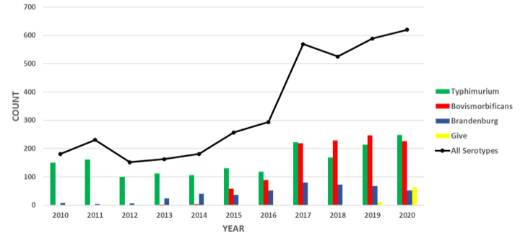

Figure 1:Laboratory conﬁrmed Salmonella cases in cattle (source: MPI)

**Salmonella is also an increasing cause of food poisoning in humans,** representing a risk to the health of farm workers, their families, and the general public.

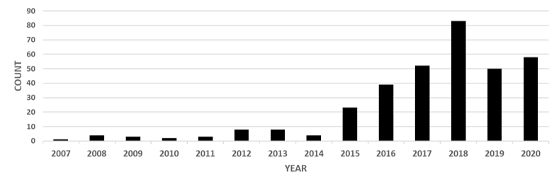

Figure 2: Notified human cases of Salmonella bovismorbificans (source: ESR)